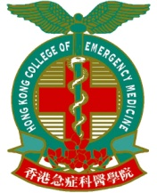 | Ultrasound Induction Course  organized by  Hong Kong College of Emergency Medicine  Ultrasound Subcommittee

Date & Time : 11th – 12th April, 2011 (Monday – Tuesday)
Time : 9:00am – 1:00pm
Venue : Tang Shiu Kin A&E Training Centre
Target : doctors who have limited or no USG experience
Fee : $500 (A&E doctors / student)
$1,000 (non A&E doctors)
Accreditation : 6 Cat A Training Points for A&E Trainees
Deadline : 14th March 2011 (Monday)
~ Application Form ~
Title: Mr. Ms. Dr. Prof. Other: Gender: Male Female
Name in English: Name in Chinese:
Hospital / Company:
Department: Rank / Post:
Office Address:
Postal Address:
Contact No.: (Office) (Home)
(Mobile) (Fax)
Email Address:
Cheque Number: Bank:
Amount: Date:
Please return the completed form and a crossed cheque payable to
“Hong Kong College of Emergency Medicine” to the following address:
“Hong Kong College of Emergency Medicine,
Room 809, Hong Kong Academy of Medicine,
99 Wong Chuk Hang Road, Aberdeen, Hong Kong”

